

https://collingham.u3asite.uk

Newsletter – june 2026

From the Chair, Chris Stothard. Welcome to the June newsletter.

I hope this image has caught your attention!
Now I’ve got it, does the u3a make a difference in your life? Have you made friends through our u3a? Do you enjoy what we offer?
Would you miss these activities if they weren’t available? If so, think of John F Kennedy’s inaugural speech about public service and commitment:
“…ask not what your country can do for you – ask what you can do for your country”
Or think of Kitchener’s poster: your country needs you. Both of these sentiments apply to your u3a. As we approach the AGM, we will be electing members of the committee who work to keep your u3a running. The old adage “many hands make light work” is absolutely true, even if it sounds like cliché.
By the time you read this, nomination forms will have been submitted and those of us who are continuing as committee members will have put in our forms. This doesn’t mean that you can’t offer your services at the very last minute as we can co-opt members at any time.
So, if my feeble rhetoric has filled you with enthusiasm and spurred you to ask “what can I do for my u3a? “ do get in touch.
Use the website to email me (https://collingham.u3asite.uk/) as soon as you read this or even speak to me after the AGM itself.
We’re looking forward to a great turnout on Wednesday 24 June at 2.00 when the brief AGM will be followed by a talk from the Air Ambulance (well not the helicopter itself, this isn’t Harold the helicopter from Thomas the Tank Engine after all).
It’s quite true: your u3a does need you. See you Wednesday, Chris
___________________________________________________________________
A message from the Treasurer and Membership Secretary
Thanks to all members who have completed a Gift Aid declaration. There is no time limit to declarations, so if you haven't done so yet but would like to, then either download and complete a form from the website or request one from the membership secretary (cwstothard@gmail.com).
___________________________________________________________________
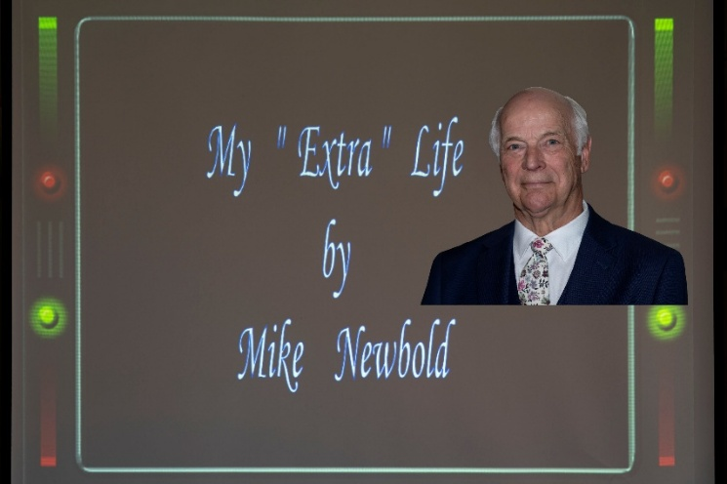
General Meeting

There was a good turnout, despite the heat, for this interesting and entertaining talk by Mike. His clear speech, interesting anecdotes, and illustrations gave us a clear idea of life as a film and tv ‘extra’.

We learnt that through his daughter’s employment with the BBC he was invited to visit the filming of an episode of Last of the Summer Wine, taking place at Holmfirth. Here, he met the producer, who invited him to be an extra in one of the scenes, as ‘The Man’ (walking by and saying ‘Good Morning’ to one of the main characters!)
Filming outdoors requires many people and much equipment including recreational and costume vehicles, known as Winnebago’s, strict guidelines to observe, and the need for prompt attendance!
This led to a twenty-year life as an extra in various programmes, including Downton Abbey, Doctors further work with Last of the Summer Wine and some films. On occasions, Mike acted as a ‘stand in’ for the main lead actors when lighting and the set-up of scenes was planned before the ’shoot’.
With a clear interactive presentation, we found out what being an ‘extra’ requires: - an equity card, an agent to provide work, early starts, various ‘roles’ (you can select these preferences that you would consider: - nudity, close ‘romantic or sex scenes!) Also very importantly, not speaking to main actors and being in the correct place at the correct time!
Mike told us Expenses are paid, meals of an excellent standard, but being an ‘extra’ is not necessarily a pathway into a full acting career or being ‘discovered’.
Mike spoke effortlessly for over an hour, clearly and with humour, providing us with information and entertainment. R Sz
___________________________________________________________________
Speakers Corner
June 24th Lincs & Notts Air Ambulance – Mission Impossible 2

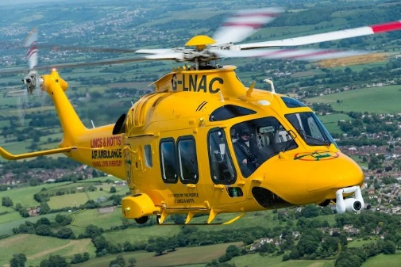
Every day crews from the Lincs & Notts Air Ambulance respond to an average of 4 life-threatening emergencies across a 3,500 square mile area. They are now on a mission to bring a second helicopter to the skies over Lincolnshire and Nottinghamshire, saving even more lives.
Twelve years on from their previous visit to Collingham u3a we find out what’s changed

July 22nd On Parade – State Funerals and Coronations

A unique insight into how large-scale ceremonial events of recent years were put together by the Principal Director of Music for the Royal Air Force

Presented by Piers Morrell OBE MVO

Following the recent visit by Nottinghamshire Blood Bikes, I received an email from Chris Perkins who was one of the speakers with the news that they had raised a magnificent £263 through donations from our members who attended on the day. He expressed his heartfelt thanks for the contributions to keep the bikes on the road.

Coming Soon

Please note, there will be no General Meeting in August.

September – It’s Hell on Wheels being a Driving Instructor

October – Re-unification. The most exciting railway project in UK railway preservation

November – The History of Busking and Street Performance

Many thanks for all the suggestions and contributions regarding Speakers. When making suggestions please supply a current email contact. We try to promote a varied programme and we know not all subjects will be appreciated. However, your attendance and feedback on recent events is welcomed. dp
___________________________________________________________________
Groups
Contacting Group Leaders

If you need get in touch with any group leader, please use the contact page on our website:
https://collingham.u3asite.uk
___________________________________________________________________
Photography
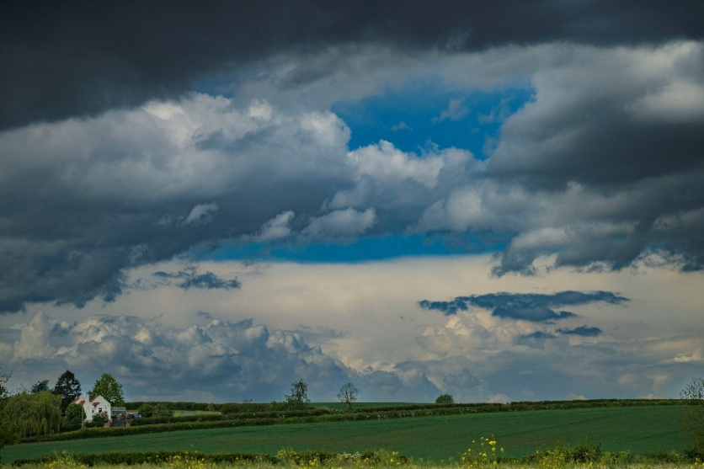
This month our images are from May.
The weather this May i.e. Dull Days, Storms and a Heat Waves, tested our skills. On dull days the light is flat and so are images. On stormy days you get soaked and try to keep your gear dry. At this time of the year the sun is very bright and the light has very high contrast. Next month we will be showing images from June
Angry Sky by Paul Bass Paul
___________________________________________________________________
Threads
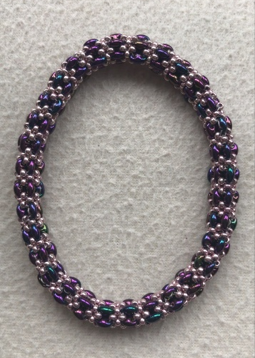
A piece of bead-weaving jewellery for you to admire this month that has a special feature – it does not need a fiddly clasp to fasten, often a tricky feat to complete without help. This bracelet rolls over clenched fingers onto the wrist and fits the owner perfectly. The joining of a clasp to the bead- weaving can be a vulnerable element of a bracelet, avoided in this case.

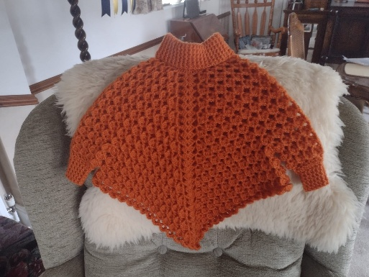
I expect that many of you know that all crafters have left over materials that are put in their “stash”. There is rarely sufficient to complete another project without purchasing extra resources.
So, imagine the deep satisfaction when the child’s hand-crocheted poncho [picture here] was completed using two strands of machine yarn and only a miniscule amount remaining!
This led to reminiscences about the “old days” when we would visit our local wool shop where, having selected a design from the many pattern books, we could ask the shop to put by a substantial number of balls [very olden days skeins to be wound at home before starting] and return to the shop to purchase more as needed. That way it minimised left-overs and an ever-growing stash. How different today, when both patterns and yarns are often bought online and any surplus goes – you’ve guessed, in the ever-increasing stash!
Our next meeting is at Beyond Coffee on Thursday 2nd July at 2 pm.
Barbara
___________________________________________________________________
Bridge
The Bridge players continue to meet weekly in Beyond Coffee 2pm - 4pm on Fridays. Chris D
___________________________________________________________________
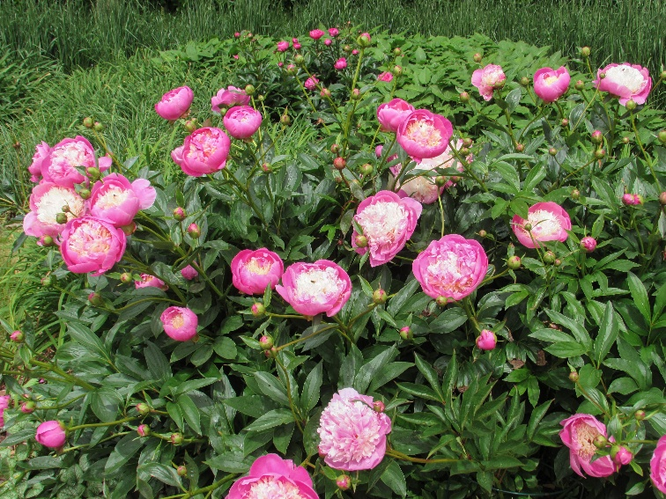

Peonies by David Jennings

__________________________________________________________________
Breakfasters
Reg Taylor’s garden centre, Southwell, lived up to our somewhat lofty expectations.
The food was served very quickly and was hot and freshly cooked. All the drinks were served at the right time and the coffee drinkers got their double shots-enabling them to keep buzzing all day. My gluten free, and caffeine-free options were ok as well.
But I do have to have one minor grumble - don’t I?
Why does a garden centre have to use fake plants to decorate their lovely cafe?
But all in all, it was a good venue.
Next time we’re at The Coach House, Doddington Hall - should be good
- I wonder if there are any plastic plants? Lesley
___________________________________________________________________
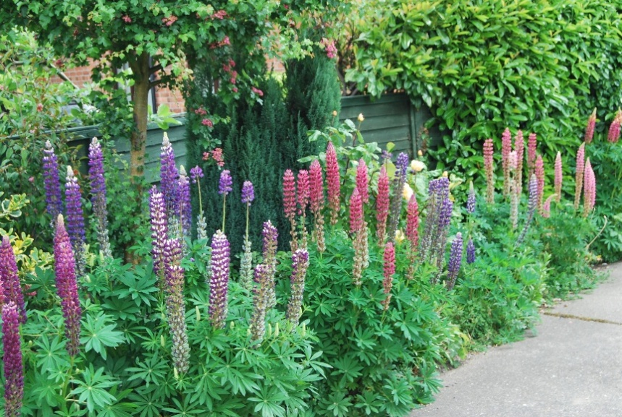

Lupins by John Geeson

Creative Writing
In place of a report from Creative Writing - no meeting this month - this was written by me a couple of years ago. Lesley
Nobody saw him as he swam too far, into the depths of his darkened soul Far too far out he kept his pace, with stronger strokes and supposed race
But one kept calling him back to land as he looked forward to heaven And then backwards to sand. How far he went he needed not know As he powered on forwards in swifter flow
But one kept calling him back to land As he kept on flowing with stronger hand How far is too far? The stranger asked. As he strode to give his energy blast
“I’ll keep onto the end “his own mind did sound But one kept on calling him back to land. The face now shone brighter in his mind so unclear With a voice so serene in his muddled-up ear
The one who kept calling now took up his hand And welcomed him back to the far distant land As he sat and he wondered what dream had occurred When swimming too far when his mind was so blurred.
“I saw a bright light which I followed with love As I kept on swimming with thoughts of above” But the one who kept calling him back to the land Just nodded and smiled, and felt for his hand.
Welcome back to us all, just rest for awhile While we test and we probe and we look at your file And the one who had called him back to the land Still stood and smiled at his healthier tan.
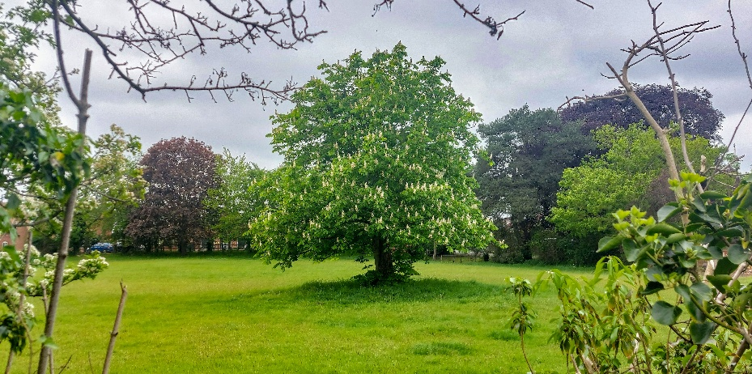
_________________________________________________________________________________

Lonely Tree by Andrew Roberts

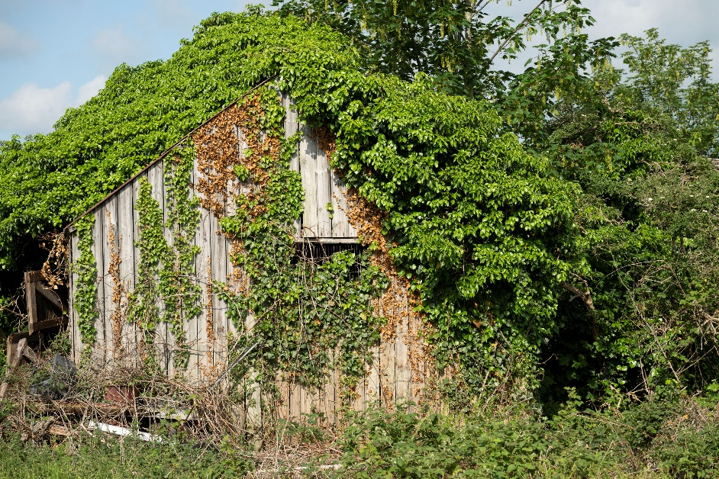
The Old Stable by Paul Bass

___________________________________________________________________
Strollers
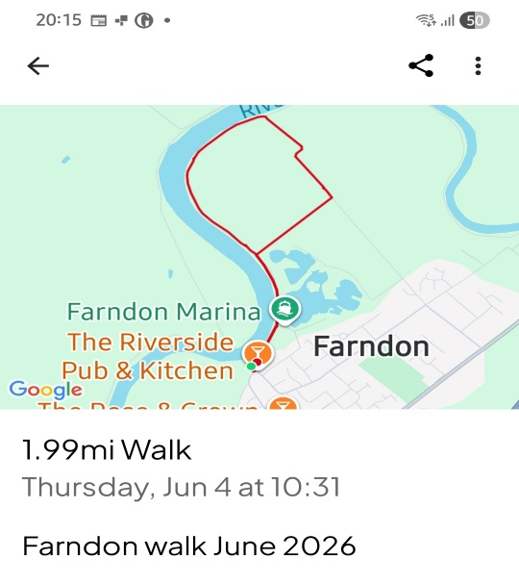
17 walkers met for a Stroll at Farndon. We walked from the riverside car-park, past the marina for a 2mile circular walk along the River Trent passing Staythorpe Power Station, then turning away from the river to return to the starting point. We walked on grass and gravel paths and passed through a small woodland area. The weather was cool, the clouds grey and we had a ten-minute shower. Fortunately, we were all prepared for rain.
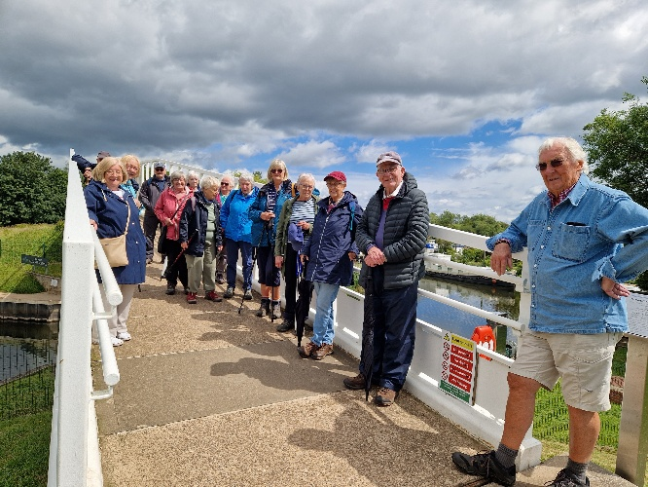
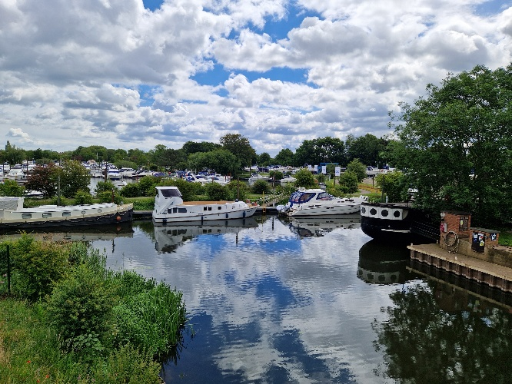

Following the walk the majority of us went to the Rose and Crown in Farndon for lunch. Rosie and Marg
___________________________________________________________________
Table Tennis
Our friendly table tennis group meets usually every 2nd and 4th Thursday of the month from 10:00 to 11:00 am at the Winthorpe Community Centre.
Afterwards many of us go to the Lord Nelson for a coffee/tea and a chat. Peter
The dates going forward are as follows:
June 18th 10:00-11:00 am - “ - NOTE: THIS DATE IS OUT OF SEQUENCE!!!!!**
July 9th, 2026 - “ -
July 23rd, 2026 - “ –
August 13th, 2026 - “ –
August 27th, 2026 - “ –
September 10th, 2026 - “ –
September 23rd^{h}, 2026 - “ – NOTE: THIS DATE IS OUT OF SEQUENCE!!!!!**
October 8th, 2026 - “ –
October 22nd, 2026 - “ –
November 12th, 2026 - “ –
November 25th, 2026 - “ - NOTE: THIS DATE IS OUT OF SEQUENCE!!!!!**
December 10th, 2026 - “ –
** Date changes due to Hall not being available on our regular date
___________________________________________________________________
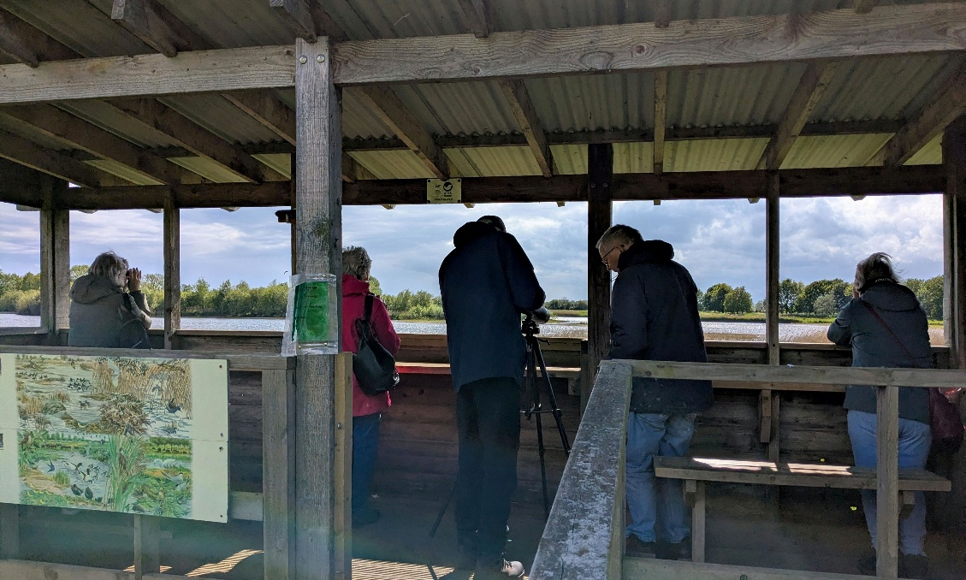
Besthorpe Birdwatchers by Pat Morgan

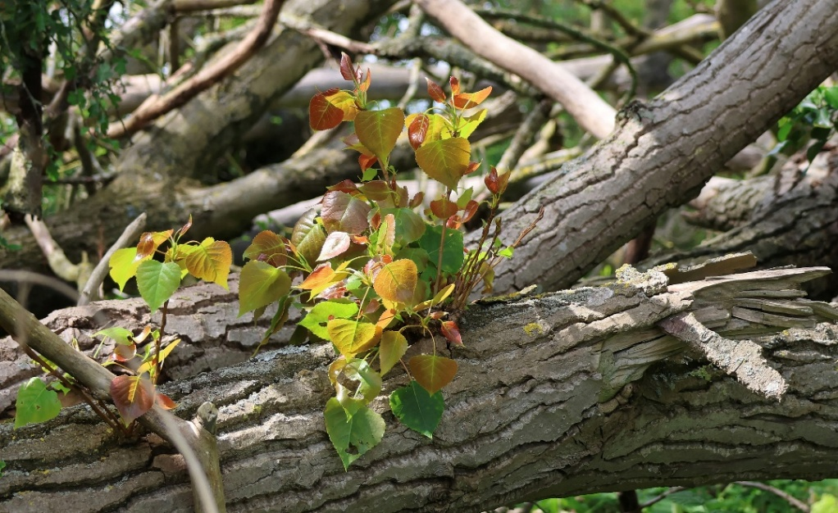

Surviving the Fall by Jannet Wright

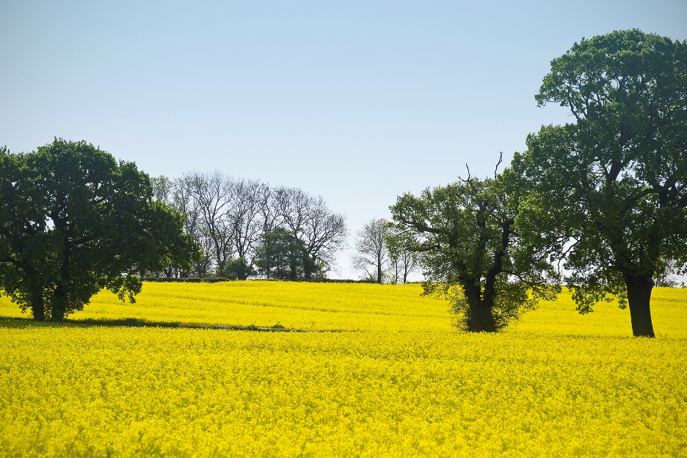

Oilseed Rape in Flower by Gill Bass
___________________________________________________________________
Thursday Talking Shop
The subject for our May meeting was: 'What Do We Mean by Truth?' In today's world, this seemed a particularly relevant topic. Indeed, there was considerable discussion about the definition of truth and, in fact, a precise definition defies certainty. We looked at various theories, for example - a statement is true if it corresponds to facts or it is logically consistent. The conversation moved on to look at how truth must play a central role in the sciences as a goal of enquiry, and we also touched on the belief in truth as handed down by divine sources in the various religions and the importance of truth as a guiding norm in the fields of ethical law and journalism. The subject for our next meeting on the 25th of June will be: 'The North/South Divide'.
Anita
___________________________________________________________________
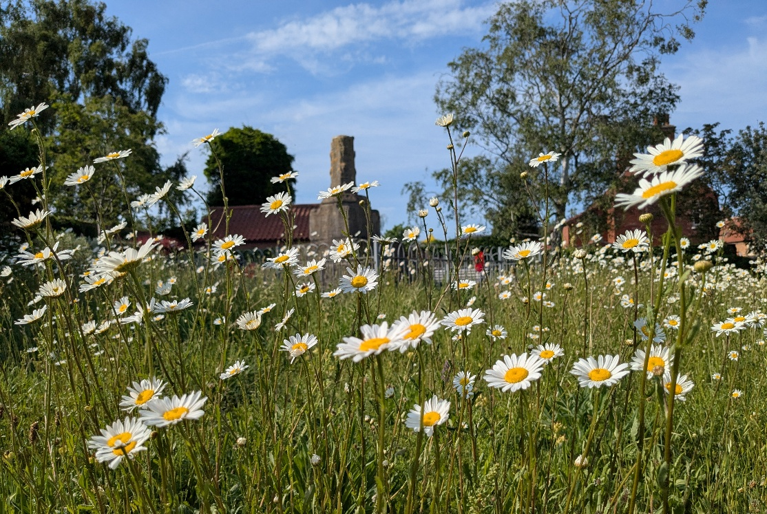

Daisies Round the Cross by Pat Morgan
___________________________________________________________________
Drawing
We met at Penny Snooks lovely house and were delighted to be given a proper lesson on “perspective” from Penny (former Art teacher)
Ok, so I thought I’d already got this one in my mental portfolio, but some of the aspects covered were completely new to me and I found it completely fascinating-e.g. the perspective needed when drawing an ellipse-wow! (ellipse-top of a plant pot for example)
We are all hoping that Penny will give us another “master-class” sometime, possibly a “short course?” Penny is a really super teacher.
This is such a lovely, supportive and chatty group. We went on to discuss everything from “do we believe in ghosts?” to the problems that those of us on gluten-free diets have: an eclectic mix I’m sure you will agree.
Our next meeting will be at Penny’s daughter’s house in Vicarage Close. Penny assures us that there are lots of items that we will be able (to attempt) to draw - can’t wait! Lesley
___________________________________________________________________

Family History
Due to many members being away we did not meet in June.
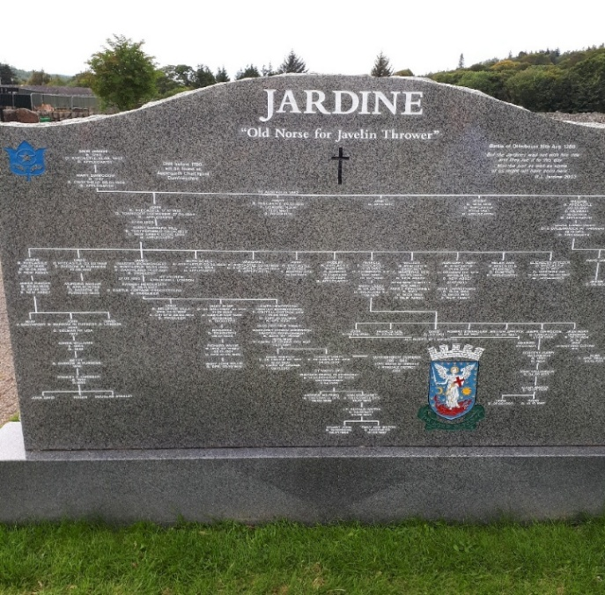

So here is a photo that Alan showed us at May's meeting. We all agreed we had never seen a gravestone quite like this before. I hope whoever commissioned it didn't make any mistakes in their family tree - a bit expensive to correct it!
We will meet as usual on Tuesday 7th July. Charlie
___________________________________________________________________
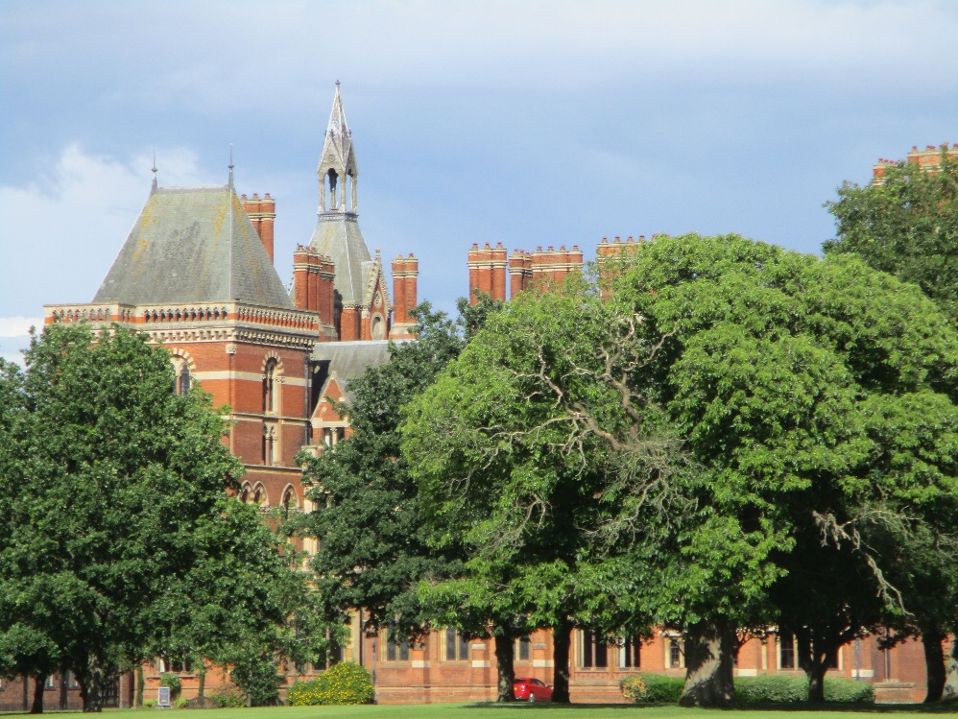

Kelham Hall by John Geeson
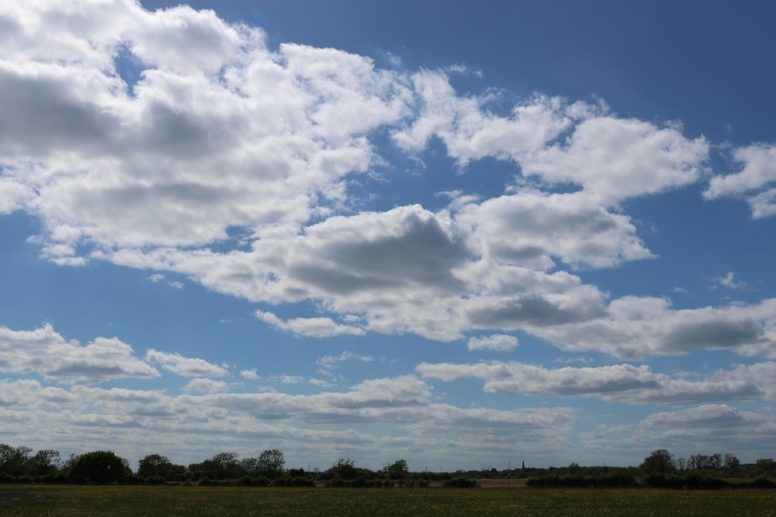

Cloudscape by Jannet Wright

___________________________________________________________________
Local History
There were three presentations this month. Paul presented his, called ‘People of Britain’, which was a wide sweep around our locality demonstrating the extent to which history, in its many aspects, is all around us.
David’s talk covered certain aspects of Girton village’s old 17th century houses followed by a discussion of the very wide sections of the Fleet River between Girton and Besthorpe called ‘Girton Strakes’ as seen on old maps. They are still seen in the landscape today. Many authorities consider this to be evidence of the former course of the Trent. A stretch of water meadows on the east of the village is where a spur off the Trent fed the meadows with nutrients during times of flood.
Continuing with the theme of villages Lesley read her interesting paper to the group about old Swinderby. David
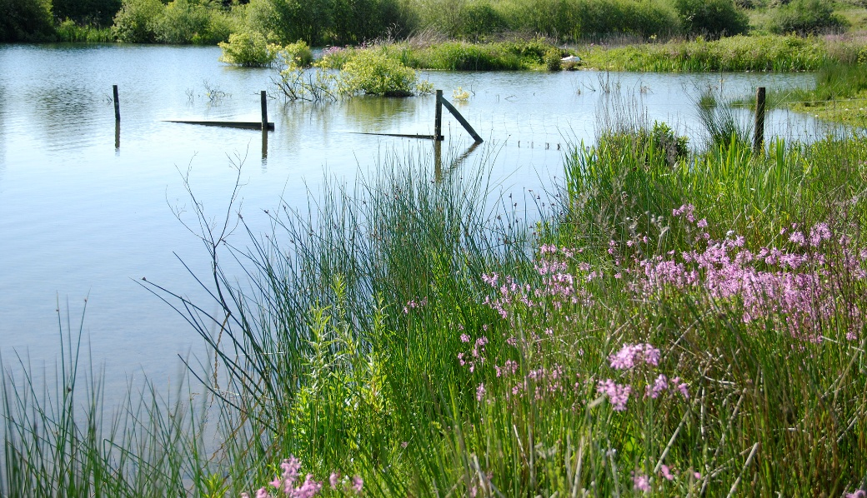
___________________________________________________________________

Ragged Robin by Gill Bass
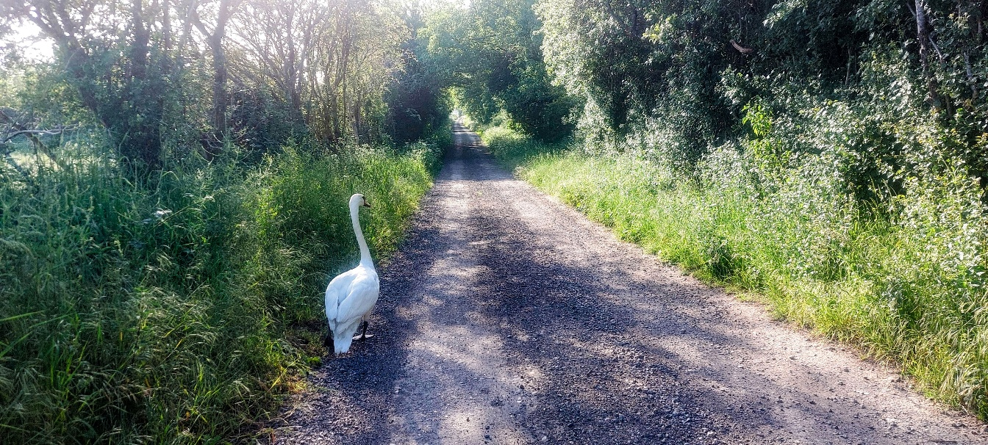
A Long Walk to the Trent by Andrew Roberts
___________________________________________________________________
Weekenders
Our last meeting was held in The Royal Oak, but future meetings will be held at the
Youth and Community Centre, Low Street on the 3rd Saturday of the month. The next meeting will be June 20th 10.30 am.
A few of our members enjoyed a visit to Doddington Hall where we had a look around the shops, a pleasant lunch followed by a walk in the garden.
We have made an early booking to visit MONET’S Gardens and Versailles Palace in May next year, at present 5 of us are going.
We supported the Plant Fayre in Clifton Village at the end of May. Chris D
___________________________________________________________________


White Lupins by David Jennings

Nature Walks
On Friday 5th June we started as a small group in the car park at Mons Pool, which gradually got smaller as members left for other commitments. Eventually I was Billy-No-Mates and added a couple of records that nobody else saw or heard. We did walk all the way round as we were lucky that there was no rain so we didn't have to stay in the hides.
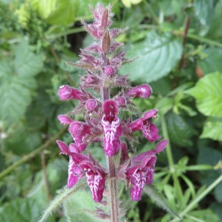
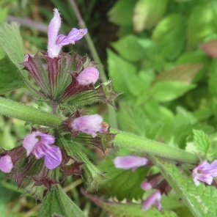
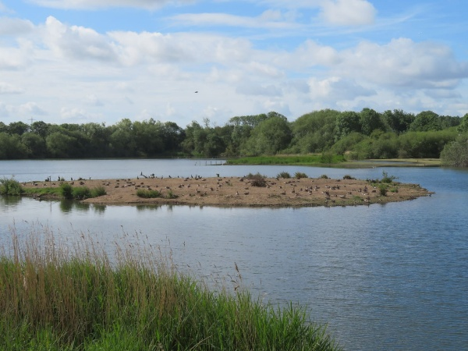
We focused on birds, and did very well. Highlights were a small number of Avocets, a very late male Wigeon (injured?) and some very loud, close Cetti's Warblers - which mostly remained hidden. I was glad to find a hybrid Goose (Canada x Greylag) which I've seen elsewhere, but I'm not sure if many others share my enthusiasm! Despite not really looking for plants, we found a few new species for the site:
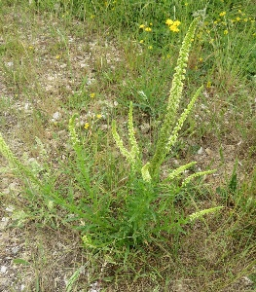

Weld Hedge Woundwort Black Horehound
We also saw a Speckled Wood and a Painted Lady butterflies - there has been an influx of the latter this year, Chris told us.
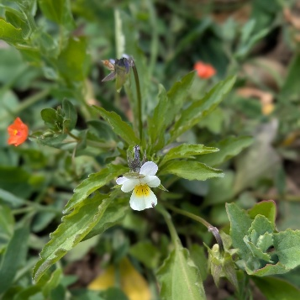
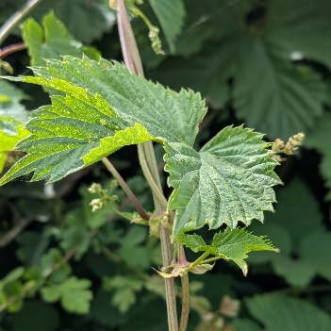
A small group visited two places around Collingham Pits on Tuesday afternoon, 16th June, mainly looking down for plants. Our chosen locations were found earlier by Robert and had escaped the sprays that make many fields almost sterile - they were two oases of biodiversity! It was pleasantly warm and we found many new plants and a great variety, far more than we've ever seen on a walk. Highlights included some taxonomic oddities - Hop, the only UK representative of the Cannabis family, White Bryony, the only UK representative of the Cucumber family and Scarlet Pimpernel, a member of the Primroses, despite having bright red flowers.
Hop Field Pansy and Scarlet Pimpernel
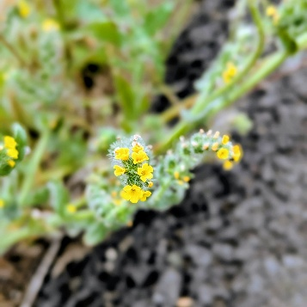
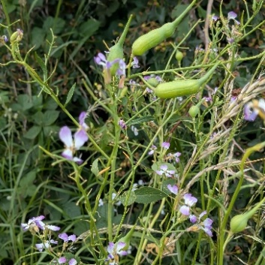
We also saw the unusually named Fiddleneck, a plant called Redshank, Wild Carrot and Wild Radish.
Fiddleneck
Wild Radish with its unusually large seed pods

Despite this focus we did quite well for birds, though most are now quite elusive, spending their time feeding young and were only heard. A few species continue to sing through the summer, though many have stopped. We managed three new species for the year, including a flock of House Martins over a field of shallots, some on the ground, perhaps collecting mud for their nests, as the field had been irrigated.
Robert ___________________________________________________________________
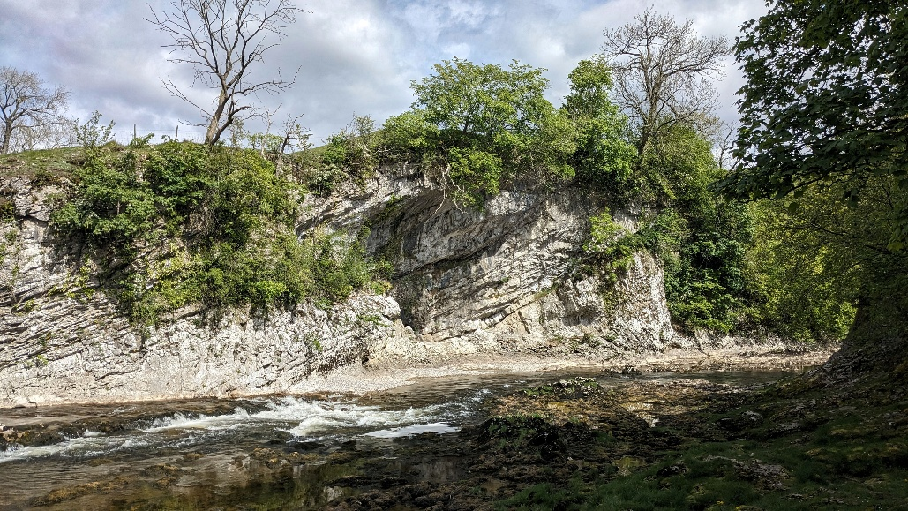

The River Wharf by Colin Smith

_________________________________________________________________________________
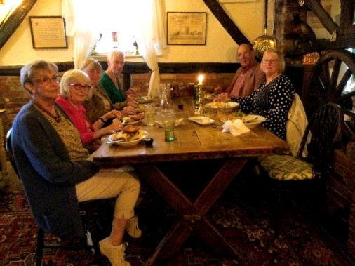
Sunday Lunchers
For our June’s u3a Sunday Lunch, a smaller number than usual of us, visited The Five Bells, at Bassingham, and had a most enjoyable meal, with very efficient staff.
Because of the holiday season, it has been decided to not meet in July and August, and then resume again on 13th September. Margaret
___________________________________________________________________
The Critics
The holiday season seems to have kicked in, we managed only four people this month, with an extra joining us at the end of the session.
We started with a book recommendation, Great Circle by Maggie Shipstead, about a female aviator, set in the 1920s. The reader felt that the writing was so convincing that it felt like a nonfiction account, but perhaps unlike nonfiction in that the reader was drawn into the story. A lively discussion followed about the power of fiction to spark an interest, especially within our group, in history, but for some in geography and even current affairs.
A newspaper article about the latest Royal wedding started a conversation about the place of the monarchy within our society, its value as a figurehead and tourist attraction and what could possibly replace it.
Having joked that meeting this month might be ‘just about the football’, the next topic was the TV documentary Dear England, about the period that the English football team was managed by Gareth Southgate. The documentary emphasized his attempts to build a team spirit that was inclusive and non-judgmental. He also introduced the use of psychiatry to give the players the ability to cope with intense pressure, which could result in both success and failure, and the resilience to cope with the latter. The ensuing discussion ranged from tennis to darts, snooker and cricket. One member also recommended a documentary shown some time ago, Freddie Flintoff’s Field of Dreams, where reluctant teenagers are introduced to cricket, transforming some of their lives, but also being a way for Flintoff himself to recover from a trauma.
In a move away from books, films and TV we finished the afternoon hearing about the pros and cons of holiday cruises, the way in which they could allow people to have experiences that might not have been otherwise possible, as well as the occasional mishaps that can occur. Pat H
_________________________________________________________________________________
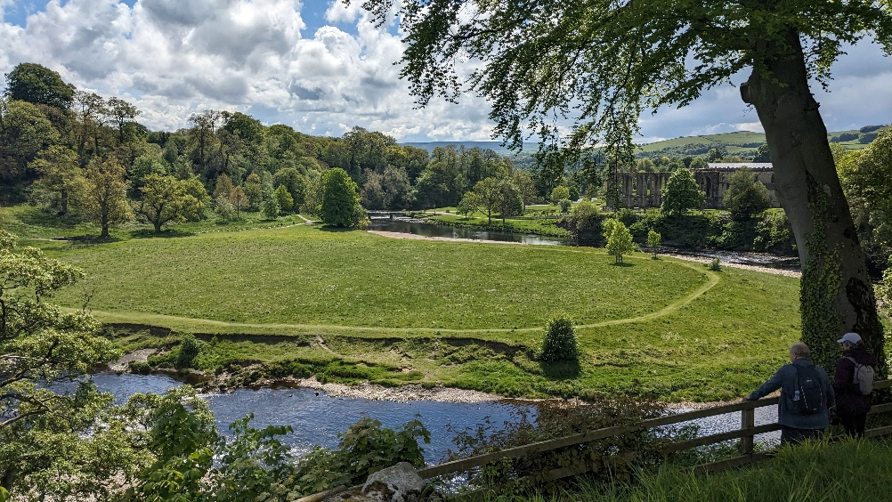

Bolton Abbey Grounds by Colin Smith

Quiz
Another interesting & exciting quiz which went down to a tie break. It is amazing that each month even with the different mix of teams we always seem to have very close results with all of the teams.
A new member enjoyed the morning so much, she has volunteered to do the next quiz or it might be her form of revenge for not being on the winning team this month.
Here are 3 of this month’s questions:
1.What is the 2nd largest Mediterranean island?
2.What famous landmark was built in 1961 but lasted only 28 years
3.What is the preferred food of a silkworm?
Answers below… John A
___________________________________________________________________
Play Reading
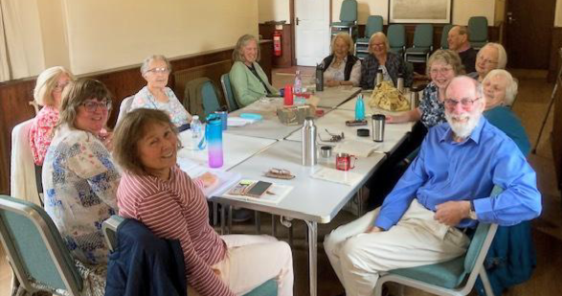
This month we completed Agatha Christie's "Murder on the Nile"; a typically convoluted plot with melodramatic twists, turns and red herrings along the way before all was revealed.
Next month we have a one-act play by reliable Alan Ayckbourn, which promises humour and plenty of parts to go round.
Before then, however, a few of us are off to see "Quiz" by James Graham at the Robin Hood Theatre.
Sue
___________________________________________________________________
Quiz Answers
1. Sardinia
2.Berlin Wall
3.Mulberry leaves
___________________________________________________________________
Fantasy Football
‘They think it’s all over. Well, it is now.’
And if you don’t know who said that and in what context, the phrase ‘60 years of hurt’ probably means nothing to you either. Personally I really hope England win it again this time round if only so we never have to listen to that infernal song again.
To be fair it’s pretty much been over for quite a while now with millers11 managed by Charlie Stothard - Collingham’s answer to Sir Alf Ramsey - leaving us all in its dust.
For some perspective Charlie won our own little league by 124 points and of the 13.1 million people worldwide who played this season, Charlie placed 845,456 which puts him well inside the top 7%. So well done to you, Charlie.
I had planned to finish on a high by posting a video link to the season’s edited highlights but unfortunately I’ve misplaced the memory stick with the clip of me punching the air in ecstasy when the guy at The Allotment put the 8th stamp on my card and I got a free cappuccino with sprinkles.
And that’s it from me until sometime in August when it all kicks off again.
Oh yes, the quotes:
Jose Mourinho, doubting an opposing player is actually injured: ‘He’s holding his face. He must have hurt his knee’.
And Dmitri Shostakovich getting football is not just 22 players chasing a ball,
‘Football is the ballet of the people’ John
___________________________________________________________________
From the Editor: John has reminded us that there’s a football competition taking place at the moment. For anyone who isn’t bleary-eyed after late nights watching the matches or all those who don’t follow the beautiful game, there is plenty to entertain you in our u3a calendar! Maybe you’ll try a new group this summer! If you still have a couple of hours to spare, you might even like to consider joining your committee!
The deadline for our July newsletter needs to be a little earlier than usual, I’m afraid: before noon on Thursday 16th July, as I need to send it out that evening. Please don’t wait for a reminder, but send any contributions after you’ve had your meetings and I will hold them over to the following month, if need be. Pat M
___________________________________________________________________----------------------------------------------------------------------------------------------------------------

