

https://collingham.u3asite.uk

Newsletter – May 2026
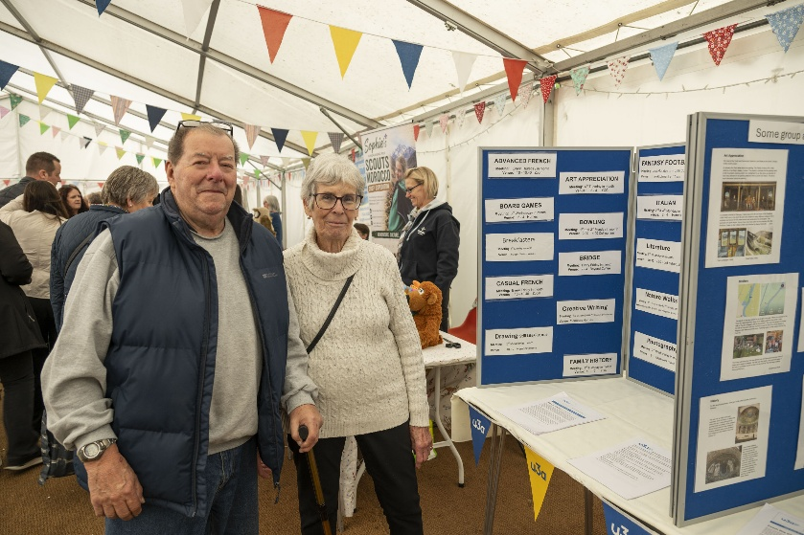
From the Chair: Welcome to the May edition of the newsletter.
I hope many of you attended the May Fair along with lots of other visitors from far and wide.
If you came and looked at our stall in the marquee, you will have seen the teddy tombola next to us. Bravo to mother and daughter for travelling down from North Yorkshire, even when they discovered that the Collingham May Fair was in Nottinghamshire not in the village near Wetherby! Jenny and Ivor at our stall, next to the Teddy Tombola
We are fast approaching this year’s AGM and this is the usual appeal for people to come forward and offer their services. It is vitally important that you have a vibrant committee with new ideas and enthusiasms as well as stalwart members of some years standing. Without the four executive officers: Chair, Vice Chair, Treasurer and Business Secretary the u3a will fold. Fortunately, the Treasurer, Vice Chair and Chair are willing to stand again this year, but Sheelah, having done a four-year stint is retiring this year as Business Secretary, so this post needs filling. If you don’t feel ready for an actual named post, but would like to learn more about how the u3a runs we have up to three vacant places on the committee which will ease you in.
We’re a really successful u3a and we all want it to continue to be so. I’m just putting you all on notice that I will be stepping down as Chair next year (this is assuming no one is vying for the role this year of course). Five years is long enough to be in the role and new ideas and direction will invigorate us all. This is, of course why we need to keep welcoming new members on to the committee so that there is a succession in place. You see, all those discussions about succession planning when you were at work continue to be important even in your more thrilling retirement!
Remember: we are an organisation run by the members for the members and without all of us there is no u3a.
Enjoy the longer days and increasing warmth, Chris
General Meetings
The General talk in April was about The Nottinghamshire Blood Bikes, www.nottsbb.org
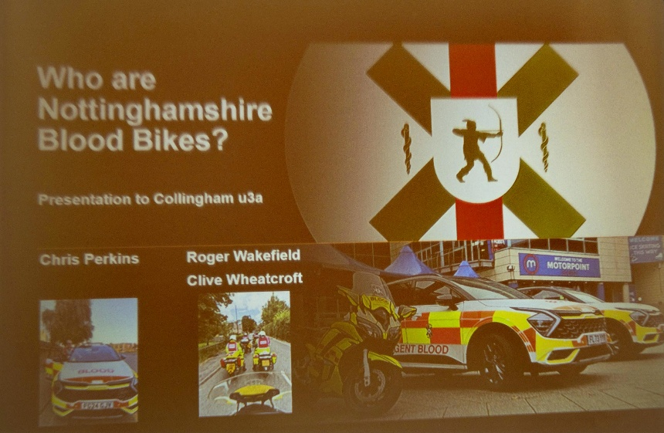
3 Members of the Voluntary Group, Chris Perkins, Roger Wakefield and Clive Wheatcroft, gave us an informative illustrated account of this charity, Nottinghamshire Blood Bikes, complete with one ‘blood bike’ that managed to be manoeuvered into the Memorial Hall!

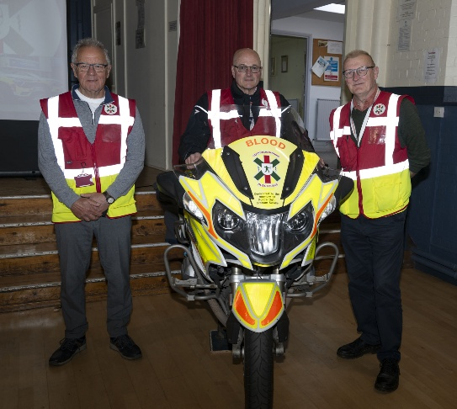
Through slides, pictures and clear explanations we learnt about the workings of such a worthwhile charity, carried out by a group of volunteers, either acting as coordinators, motor bike drivers, car drivers, mechanics and fund raisers.
The function of the Charity is to transport blood, equipment and other products requested by hospitals, hospices, pharmacies and clinics, between the hours of 6pm and 6am, Monday to Friday and at weekends.
In 1962 the first voluntary organization was formed north London and now is run across many regions of the UK.
The Notts BB was formed in 2013 and is run entirely by volunteers providing a service to the NHS and is entirely financed by fund raising. Driver volunteers, either of motor bikes or cars, are skilled drivers giving their time for a number of hours per month.
We learnt that the drivers use a number of well -maintained ex -police bikes, ex -ambulance cars, and new cars to carry out transportation.
Rules of the road are obeyed and there are no ‘blue lights’ used. Members were able to look at the motor bike in the hall at close quarters and chat with the three engaging presenters.
A fantastic talk for a fantastic organization!
___________________________________________________________________
Speakers Corner

May27th “My Extra Life”

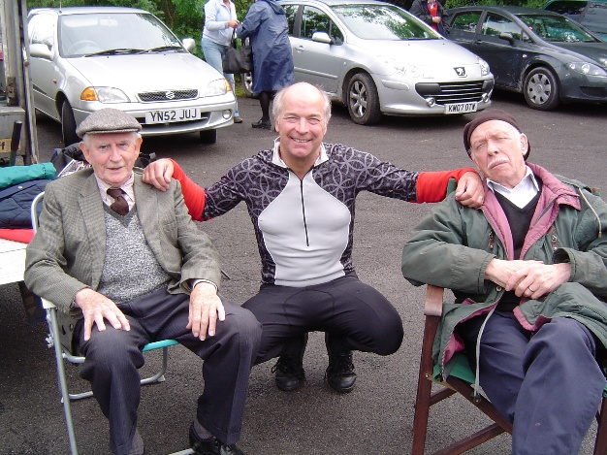
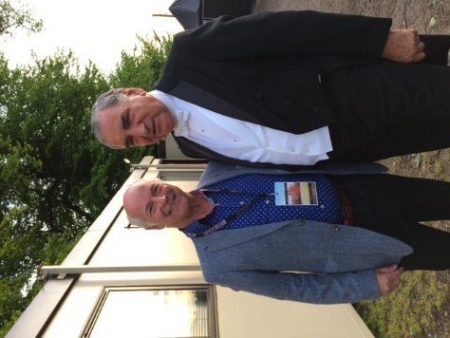
Mike has been a television extra for 18 years and has encountered some interesting and strange people. He talks about the rules and regulations, the pitfalls, the jargon, pay and his experiences.

Presented by
Mike Newbold

June 24th Lincs & Notts Air Ambulance – Mission Impossible 2

Every day crews from the Lincs & Notts Air Ambulance respond to an average of 4 life-threatening emergencies across a 3,500 square mile area. They are now on a mission to bring a second helicopter to the skies over Lincolnshire and Nottinghamshire, saving even more lives.
Ten years on from their previous visit to Collingham u3a we find out what’s changed

July 22nd On Parade – State Funerals and Coronations

A unique insight into how large-scale ceremonial events of recent years were put together by the Principal Director of Music for the Royal Air Force

Presented by Piers Morrell OBE MVO

Coming Soon

- It’s Hell on Wheels (Confessions of a Driving Instructor)
- Reunification: The most exciting railway project in UK preservation

When an event is cancelled at short notice, we need a plan B. If you have a presentation which might be suitable for a general audience and are willing to step in at the last minute, please let me know.

Many thanks for all the suggestions and contributions regarding Speakers. When making suggestions please supply a current email contact. We try to promote a varied programme and we know not all subjects will be appreciated. However, your attendance and feedback on recent events is welcomed. dp

___________________________________________________________________
Groups
Contacting Group Leaders

If you need get in touch with any group leader, please use the contact page on our website:
https://collingham.u3asite.uk
___________________________________________________________________
Strollers
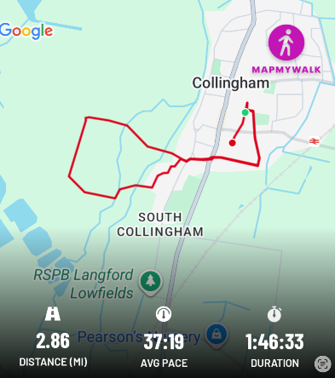
﻿
This month 21 of our Strollers did just over a 2-mile local walk around Collingham fields, lanes and paddocks (we did a slightly shorter route to Low Street than on the map attached). The weather had been heavy rain and hail before we started so we were surprised how many of our troupers turned up. We had a little light rain on route, but mostly we were lucky and it was mainly dry with a little sunshine
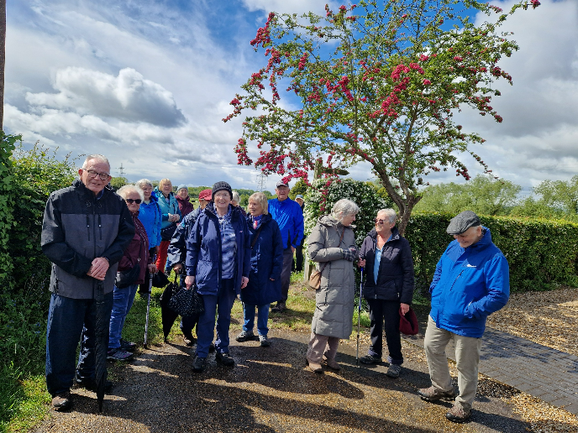
Our route was from The Co-Op to Low Street then down Westfield Lane turning left at Westfield Farm and along the track to the two iron gates where we turned left to follow a track along fields through the horse paddock to South End, then through St John’s church yard and back to the Co-Op.
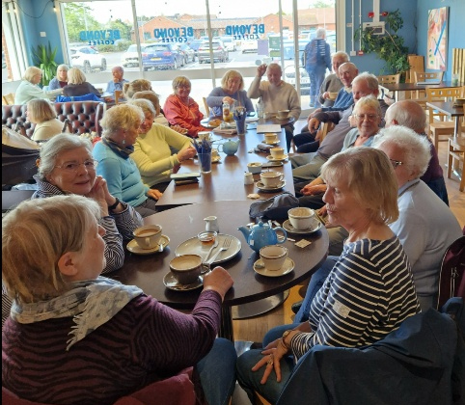

Beyond Coffee were wonderful, they reserved an extra-long table for our lunch and as usual the service and food were first class.
Many thanks to Penny for suggesting this walk, any more suggestions are always appreciated
Marg and Rosie

___________________________________________________________________
Photography
This week's images are showing the local area in April. Our members are now busy taking May's pictures for the June newsletter.
Also, this month I have added 2 images from Colin Smith from his recent holiday in the Azores. Paul
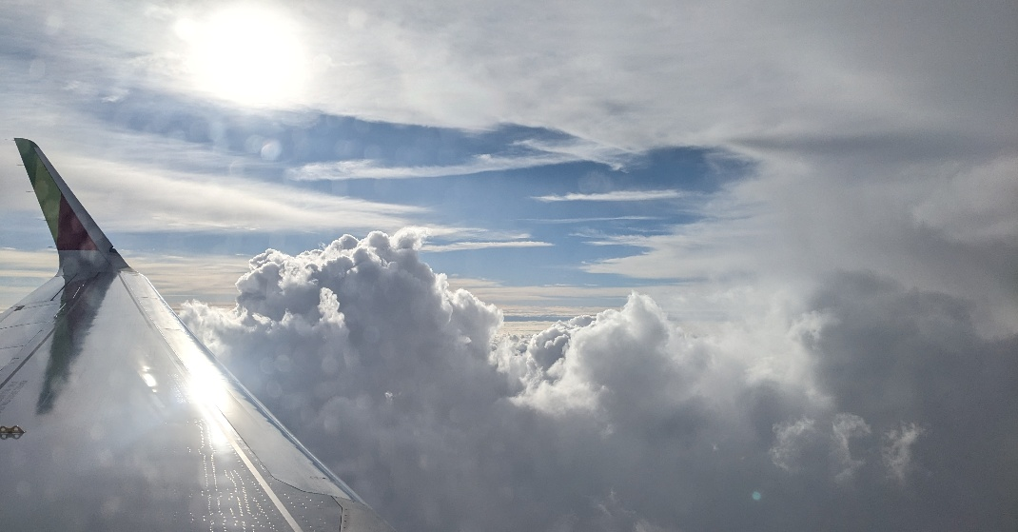

Going on Holiday by Colin Smith
_________________________________________________________________________
Family History
At our May meeting Gill and Charlie told the group about a number of websites that may be of use to family historians.
The first site, freeukgenealogy has birth, marriage and death records as well as census records and parish records. As its name suggests this is free to use and is an alternative to paying sites such as Ancestry. It contains transcriptions of the records rather than actual images but is a good basis for research.
findagrave brings together cemetery records and may contain photographs of a gravestone submitted by volunteers or relatives.
www.discovery.nationalarchives.gov.uk directs researchers to which archive in the country may hold records of interest to you.
www.geograph.org.uk was suggested as a site to look for modern photographs of where an ancestor may have lived while www. francisfrith.com contains historical photographs of British towns and villages.
To finish the meeting we looked for and found Women's Land Army record cards from WW2 for two of Jean and Tricias' ancestors. Charlie
_________________________________________________________________________
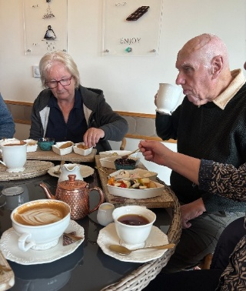
Out and About
This month 7 Out and Abouters went to Sarsfield’s Chocolaterie. Five of us sampled the chocolate fondue: choose four things from a list to dip into white, milk or dark chocolate. The two members not sampling chocolate had done that before and warned that one fondue between two was more than enough and so it proved! The couples sharing got through the lot but the singleton had, with much regret, to admit defeat.
The choice of dips was interesting. Anyone for bacon and chocolate? Stilton and chocolate? Apparently, bacon and chocolate is a pairing made in heaven whilst the cheese and chocolate got a mixed reaction: some loved it, others definitely didn’t. Fruit always goes well with chocolate but so does stem ginger (if you like that sort of thing), mini doughnuts or amaretti biscuits.
Several purchases were made at the small farm shop on site as well as the café and everyone had a great time, with vows to return with various family members. Look them up on line and it’s probably a good idea to book.
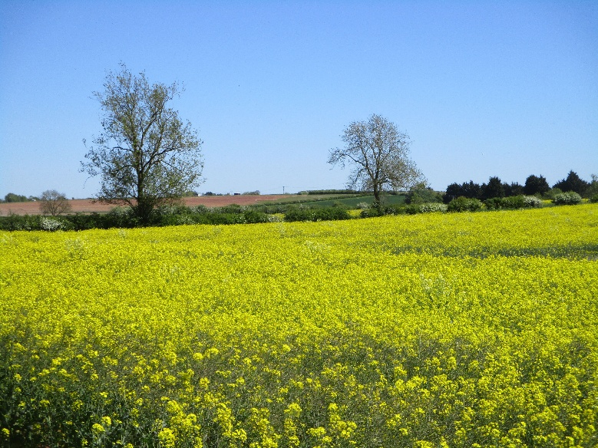
_________________________________________________________________________

Across the Fields by John Geeson

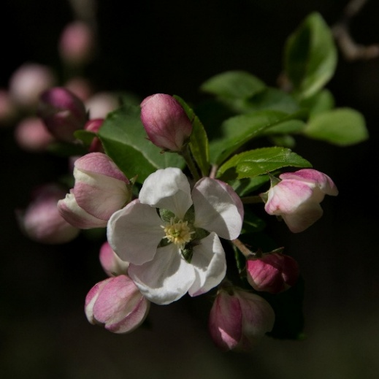

Apple Blossom by Gill Bass

Threads
Members of Threads continue to keep busy on their individual projects at home and at our monthly meetings on the first Thursdays at Beyond Coffee. We are a mutual admiration group!
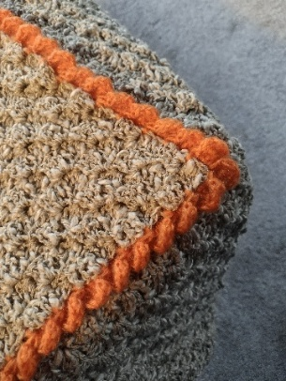
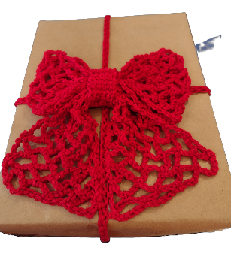


Who wouldn’t love to receive a present decorated with a fabulous topper such as these crocheted pansies or sunflower designs. The crocheted bow holds the wrapping paper without the need for sticky tape and is reusable, as is the brown paper. I can see other uses for these projects, cushions for instance and more.

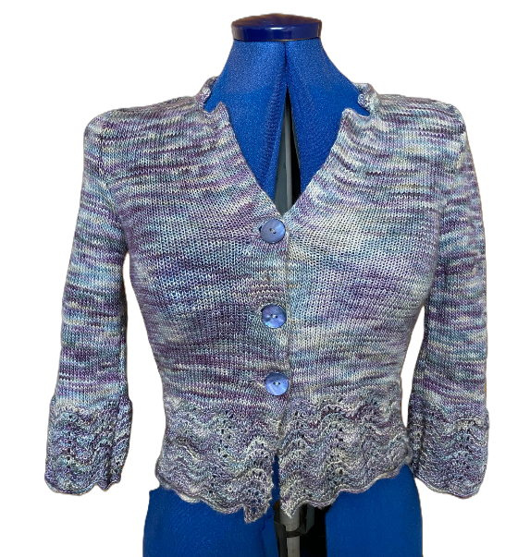
Close-up of a knee rug recently completed by one of the Threads crafters using brown slub yarn from stash and two strands of knitting machine orange for edging.
The knitter who made the purple cardigan was pleased to make it for a friend but has said, quite firmly, that this was a one-off project, not to be repeated! However, we all thought the complicated pattern was worth the effort and hope the recipient is appreciative.
Have you started something and reached a problem? Come to Threads and we will endeavour to get you going again.
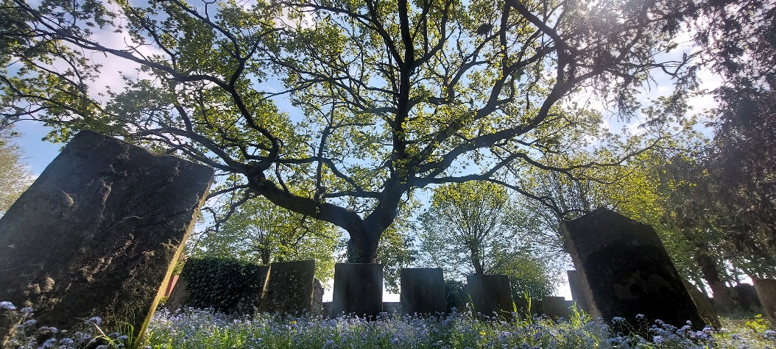
Our next meeting is on 4th June at 2pm at Beyond Coffee. Barbara _________________________________________________________________________

Churchyard
by Andrew Roberts

Local History
This month the group continued the theme of researching the history of some of our local villages. First up was Ivor who gave a comprehensive account of the 'lost' village of Meering. This included the factors that made it unique in that it had no parish church; no permanent population and its boundaries were defined almost entirely by water - the Trent on one side and the Fleet on the other. In between the land was given over to lush pasture the result of frequent flooding from its bounding rivers. This was perfect for grazing cattle and the cutting of hay. However, it did possess at one time a manor house and small settlement which was the seat of the medieval De Meering family who acquired the parish sometime in the 12th century. Four William De Meerings are recorded during the 15th and 16th centuries, one of whom has an effigy along with his wife in the nearby South Scarle church. The manor house was demolished around 1910 by then its surrounding properties having long since disappeared in the 1800s, leaving no trace. Today the census reveals zero inhabitants. A truly lost village.
Charlie had been looking into an enigmatic village name observed on Blaeu's 17th century county map – “Bernthorpe” which was possibly a map maker's corruption of Danethorpe? It depicted a church symbol in the position where 'Brough' might be expected or 'Danethorpe' as the two hamlets seem to be closely connected. Danethorpe was a settlement in Domesday. In 1086 it contained 12 households and one church. However, the current chapel St Stephen, built in red brick, was completed in 1886 and was Methodist. By 1970 Brough village was reported as practically deserted. Brough is famed for being the Roman station site of Crocolana on the Fosse Way (A46). The well-known local antiquarian Thomas Smith Woolley excavated the site and showcased his findings of considerable amounts of Roman pottery found at Brough in the Thoroton Society's publication. In the past Roman coins were found in the area so frequently that they were locally called 'Brough Pennies'
David
_________________________________________________________________________
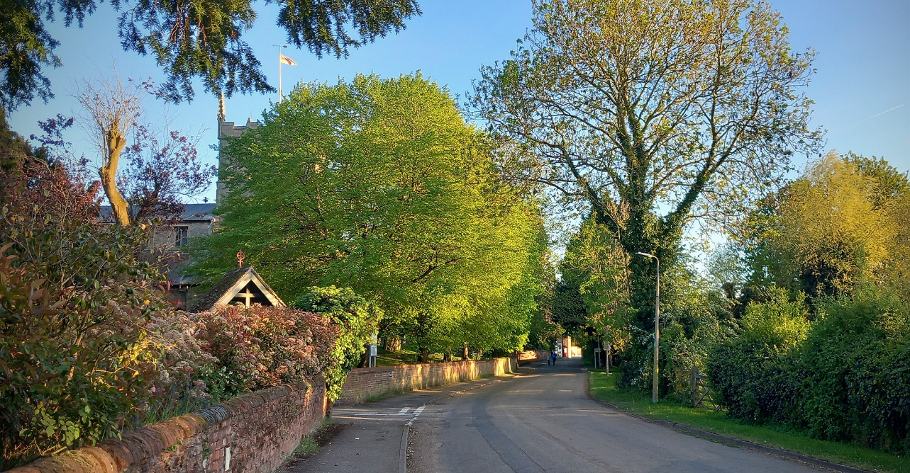
Low Street by Gill Bass
Nature Walks
In the last few weeks members of the group have made three visits to Mons Pool.
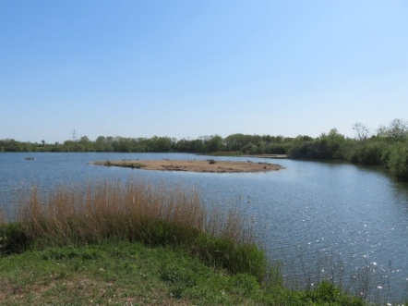
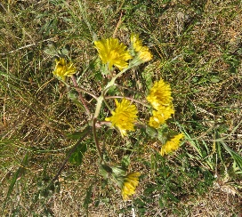
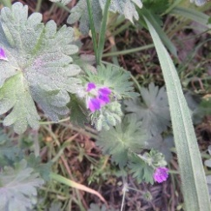
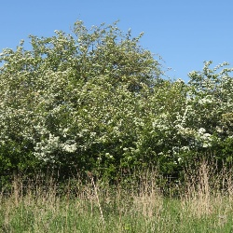
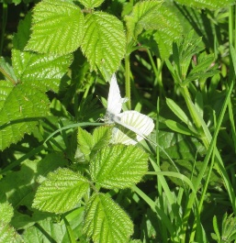
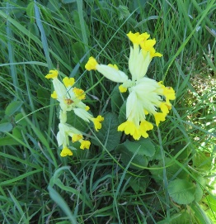
On 21st April It was very sunny, but the strong easterly wind made life difficult - many summer visitors had arrived, were singing but remained hidden. Photo opportunities were very limited! We saw four butterflies: Green-veined White, Speckled Wood, Peacock and Orange-tip but the plant list was quite good. The birds were a good variety - a late Goosander was a surprise, lots of singing (but mostly hidden) warblers, two Avocets and a new species for us, a Peregrine, perched on a nearby pylon.
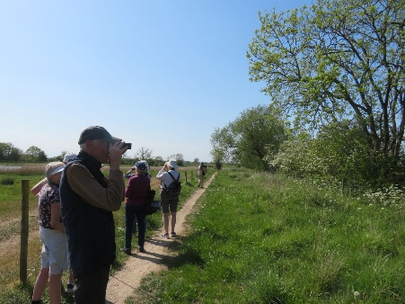
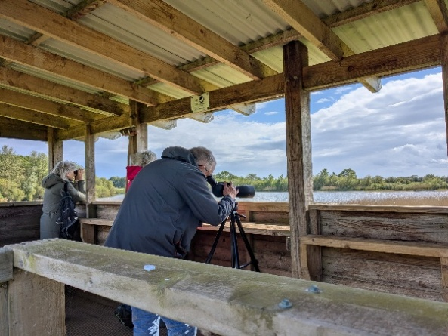
We returned on the 1st May and made some new additions to our bird list. The birds include Jay, seen by Paul as he left. Also included is Little Ringed Plover - I went back the next morning and had a better look. A local I met told me that could be breeding, do we may see them again.


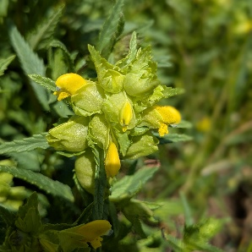
On our most recent visit to Mons Pool it was decidedly windy and cool, with occasional rain, so this may have caused the reduction in bird activity - it was very quiet! We only added cuckoo and Swift to the list from last time, and no sign of the terns or avocets, only blackcap and chiffchaff singing.
However, we more than made for this with the number of plants that had appeared. Perhaps all the rain has caused a growth spurt?
“March winds and April showers bring forth May flowers!” Robert Yellow Rattle Carder bee on Hawkweed
_________________________________________________________________________


In the Centre
By Jannet Wright

_________________________________________________________________________
Quiz
Another great quiz with some of the 'NO That's NOT Right' answers but as always, the person asking the questions is the one with the correct answer. We do sometimes have a very short 'debate' but we have to have the answer that the Quizmaster has. Sometimes that makes the quiz more fun & interesting. I was very pleased today as there were some questions about the USA which I could answer, 3 of them are:
1.In American Football, how many points are scored for a touchdown
2.What other name is the state of Texas known by
3.What is a Fosbury Flop John A

_________________________________________________________________________

Sail Away
By Jannet Wright

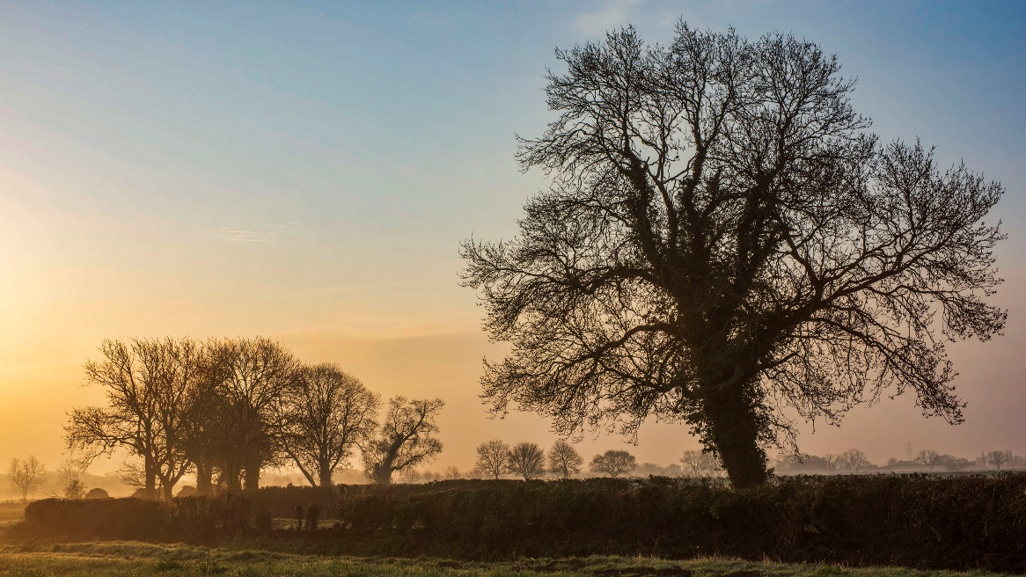

Misty Morning by Paul Bass
_________________________________________________________________________
The Critics Six people attended with two apologies.
Only one book for discussion, ‘The Ministry of Utmost Happiness’ by Arundhati Roy. Two people had read it and both agreed that it was very heavy going, possibly because the author had a very specific agenda in mind, the violence between India and Kashmir, and corruption in high places. They also thought it was too long with a bewildering cast of characters.
The play ‘Uncle Vanya’ by Anton Chekhov, seen at the Robin Hood theatre, didn’t get rave reviews. It was felt that the actors had done well with a very boring and predictable story.
On the other hand, there were many TV recommendations. The docu-drama about John Worboys led to discussion about the difficulties of prosecuting some crimes where it was hard to collect evidence, and also the past disinclination of the police to believe the testimony of women who may have ‘brought things upon themselves’.
Most people had seen at least some of the programmes about David Attenborough’s birthday celebrations, and everyone was positive about his contribution to the appreciation of nature, and ultimately his words on climate change.
The Netflix programme ‘Legend’, about a drug busting exercise run by the Customs and Excise department in the 1990s was lauded by all who had seen it, as was the ITV programme ‘Secret Service’.
The TV series Amandaland was cited, in contrast with Arundhati’s book, as a way of using humour to explore quite important issues, as well as being enjoyable and very funny.
The next meeting is planned for 18th June. Pat H
_________________________________________________________________________
Sunday Lunchers
On May 10th, our u3a Sunday Lunchers returned to one of our favourite venues, The Generous Briton at Brant Broughton.
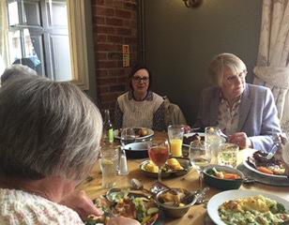
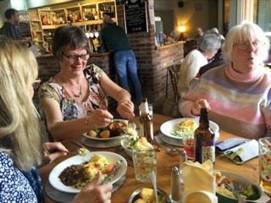

Thirteen members, enjoyed choosing from their excellent menu, and as always, we were well looked after by Danny and John.
Our next u3a Sunday Lunch is on 14th June, with venue details to follow shortly. Margaret
_________________________________________________________________________
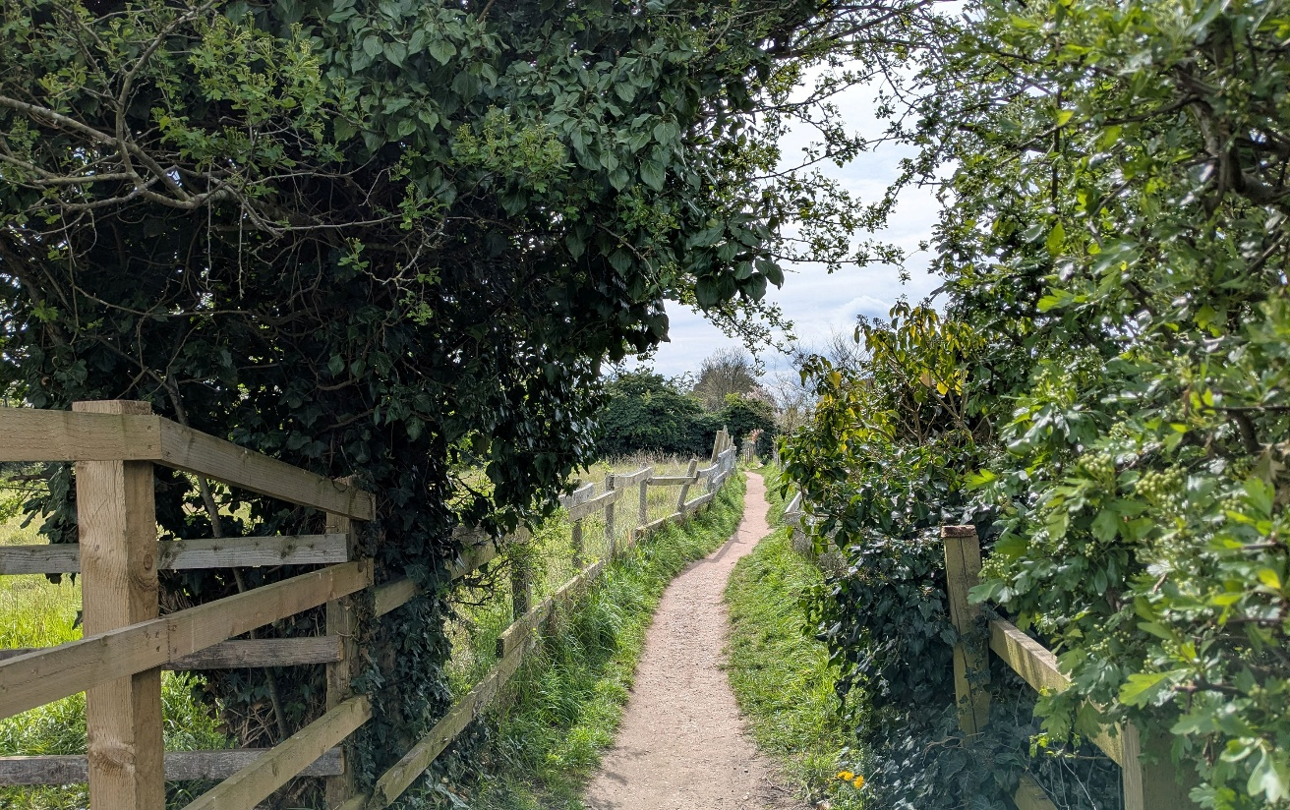

Field Footpath by Pat Morgan

Table Tennis
Our friendly table tennis group meets usually every 2nd and 4th Thursday of the month from 10:00 to 11:00 am at the Winthorpe Community Centre.
Afterwards many of us go to the Lord Nelson for a coffee/tea and a chat. Peter
The dates going forward are as follows:
May 28th, 2026 from 10:00 am to 11:00 am
June 11th, 2026 - “ -
June 18th, 2026 - “ - NOTE: THIS DATE IS OUT OF SEQUENCE!!!!!**
July 9th, 2026 - “ -
July 23rd, 2026 - “ -
August 13th, 2026 - “ -
August 27th, 2026 - “
September 10th, 2026 - “
September 23rd^{h}, 2026 - “ - NOTE: THIS DATE IS OUT OF SEQUENCE!!!!!**
October 8th, 2026 - “ -
October 22nd, 2026 - “ -
November 12th, 2026 - “ -
November 25th, 2026 - “ - NOTE: THIS DATE IS OUT OF SEQUENCE!!!!!**
December 10th, 2026 - “ -
** Date changes due to Hall not being available on our regular date
_________________________________________________________________________

Wall of Wysteria by Andrew Roberts
Literature
We have been reading ‘At the Edge of the Orchard’ by Tracy Chevalier; the story of a pioneering family of first- and second-generation Americans making the arduous journey across the continent, from the east coast to Ohio and then to California in the wake of the gold rush. At the opening of the novel, the Goodenough family have been battling for nine years to grow the requisite 50 trees that will secure their claim to their land.
The amount of painstakingly detailed research Tracy Chevalier has put into producing this historical novel gave us a lot to discuss/share at our very enjoyable get together this month.
We are looking forward with much pleasure to read ‘A Single Thread’, another Tracy Chevalier novel.
Sheelah
_________________________________________________________________________


Oil Seed Rape by Paul Bass
_________________________________________________________________________
History
The History group met on 22nd May, several people were on holiday, or had prior engagements. Therefore, we were a smaller group, but non the less enthusiastic and engaged! This month and next we are looking at scientists, both male and female, mostly from the 19th and early 20th Century. Many of the names are familiar, some not, but it’s good to look at their personal lives and achievement's. This topic continues next month when we learn more of their lives. Ann
_________________________________________________________________________

Drawing
We met at Pat Smedley’s lovely house and sat around her large dining table. Arranged on it were several ornaments and a large pot plant - most of us decided to draw the pot plant, it seemed a bit easier!
We chatted and admired each other’s work. This is such a lovely mutually supportive group, I really like it.
Next time we’re at Penny Snook's house and she’s promised to give us all a lesson on perspective: serious stuff. Lesley
_________________________________________________________________________
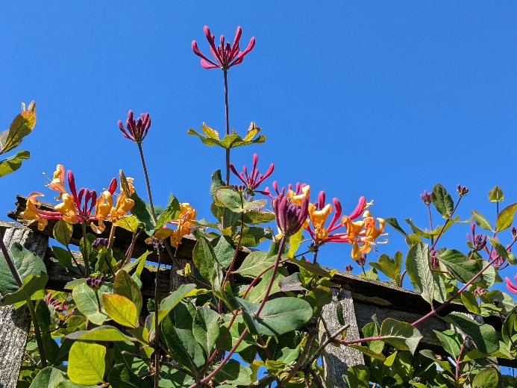

Honeysuckle over the Fence by Pat Morgan

________________________________________________________________________
Breakfasters
The Garden Centre at Downtown, Grantham, has been given a complete makeover after it recently changed ownership. The cafe was totally unrecognisable; huge and festooned with unreal (plastic) foliage. This cafe looks as if it’s going to be perfect for catering for the people on coach parties.
As they don’t allow anyone to book a table, we had to move a couple of tables together to seat 10 of us-no problem of course - we’re getting used to it!
Once we’d all ordered and paid for our food we waited for it to be served to us. There was plenty of staff, but sadly some of the very new, young staff members had a few problems locating the tables and bringing everything that was needed. Perhaps in a few more weeks everything will run a lot more smoothly.
Our food was a tale of two halves - one side of our table was perfectly happy with their breakfasts, the rest of us were not. We were distinctly underwhelmed. Cold coffee, and no jam with the toast and jam, plus other very minor grumbles.
Next time we’re going to Reg Taylor’s at Southwell. The Sunday Lunchers have given it a very good write up-let’s hope it works for us as well. Lesley
_________________________________________________________________________
Creative Writing
We usually meet at Alexis’ lovely house in Newark, but I had forgotten to put the date in my diary (blame my recent holiday!) so I got a somewhat frantic phone call from Alexis to ask where I was? Cue much haste and I’m then at Alexis dining table with a hot drink and a few pages of writing. Alexis read me her superb piece about an empty house in her own street-excellent writing! My small missive was observational, as ever, but this is a style that I enjoy exploring. Lesley
_________________________________________________________________________
Play Reading
Play Readers have been busy since last month’s newsletter. We finished reading Alan Ayckbourn’s endearing comedy, “Comic Potential” – and there was a happy ending, even if the robots seemed to be taking over … even in 1998 when the play was written.
Some of us have also been to the theatre in Nottingham to see an Agatha Christie and the Robin Hood Theatre in Averham where we saw an excellent production of the rather sad, atmospheric and angst-ridden play “Uncle Vanya” by Anton Chekov. We are back in Averham next month to see a modern play, “Quiz” by James Graham, which tells the story of the Coughing Major of “Who Wants to be a Millionaire” fame.
We have also done a bit of performing ourselves, with unforgettable (!) readings for the Cancer Research UK charity concert.
Back in the YCC this week we read the first act of Agatha Christie’s “Murder on the Nile”. And not a body in sight as yet, but the plot thickens and we will meet again on June 16th when all will be revealed - if we didn’t know already – in this famous murder-mystery.
Sue
_________________________________________________________________________
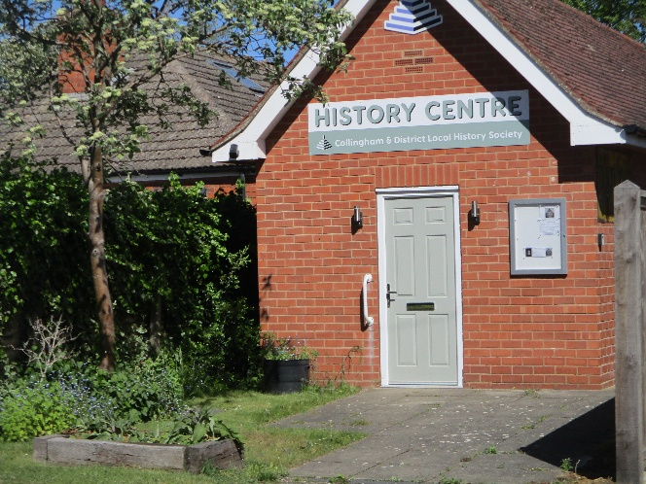
Quiz answers:
1. 6
2. The Lone Star state
3. Track & field high jump move

The History Centre by John Geeson

Art Appreciation
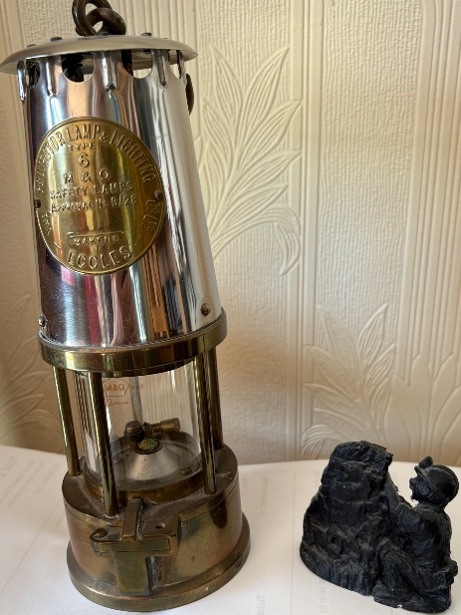
At our meeting in April, Chris Stothard talked about the Pitmen Painters, also known as the Ashington Group. The group, miners from Woodhorn and Ellington collieries, started life as the Ashington Branch of the WEA studying philosophy. When they wanted to study Art Appreciation a tutor was arranged for them called Robert Lyon. However, the content of his teaching sessions did not provide them with what they wanted. So, he suggested they create their own art work as a way to understand and appreciate art. They went on to hold exhibitions of their work and had it exhibited in London.

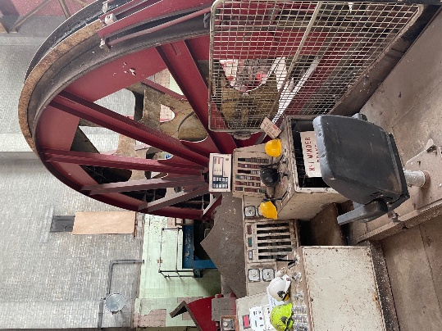
Chris introduced us to some of the main members of the group – Oliver Kilborn, Harry Wilson, Jimmy Floyd and Fred Laidler.
The critic, William Feaver wrote a book about the Group entitled Pitmen Painters: The Ashington Group 1934-1984. This was adapted as a play by Lee Hall called The Pitmen Painters. It was first performed in Newcastle in 2007 and then transferred to the National Theatre.
Photographs of a pit lamp and winding gear taken by Chris

At our meeting on Tuesday 26th May Jenny Clifford will talk to us about South African Beadwork. Jannet
_________________________________________________________________________
Italian
The group meets in the home of the group leaders on the second and fourth Monday
of each month.
In our Speaking and Listening session this month, we made up stories using photographs of people engaged in different activities and/or expressing different emotions. We worked in pairs and then told the stories to the rest of the group (in Italiano, ovviamente).
After tea we read and translated an article from an Italian magazine.

Mary and Jannet
_________________________________________________________________________


From the Editor:
It’s been an odd month: it would have been lovely to be in the Azores with the Smiths!
Once again, some Group Leaders have not had time to send a contribution. Unfortunately, it isn’t easy to change the deadline, if members are to receive the newsletter before the Wednesday General Meeting, but I am assured that group leaders will try to bring you up to date next month!
The talk on Wednesday looks most entertaining! In the next few weeks, we’ll probably find ourselves peering at our TV screens trying to spot Mike Newbold in shot.
The deadline for the June newsletter is 6pm on Friday 19th June, but group leaders can send their contributions to me any time from now on.
Pat M
The Azores by Colin Smith
___________________________________________________________________-----------------------------------------------------------------------------------------------------------------

